**Peer review activity**

Select a partner in class and e-mail your introduction to them and have them email their introduction to you. Provide respectful and construction edits and feedback **using track changes and commenting** on their introduction, assuring that you have reviewed for the following issues (*If needed, refer to lecture 10 on scientific writing & editing cheat sheet – Workshop 6*):

* Proper **structure** of the introduction - General to specific, ending with the research question
* Failure to write **concisely** and with **precision** (use of scientific, rather than colloquial words to refer to scientific concepts)
* Failure to be **clear** and **straightforward**
* **Cohesion, coherence and emphasis**
* Failure to **cite** the ideas of others
* Use of quotes, rather than rephrasing concepts in the writer’s own words

For reference, here is the rubric for introductions (rubrics for other sections are posted on BBLearn):

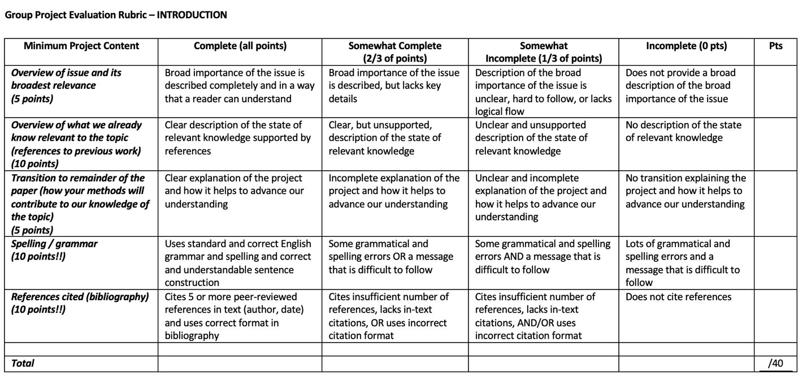

When you have completed the assignment, **upload your edits to the BBLearn submission box for this assignment and send your partner your edits**. These edits can be used to increase the clarity of your scientific writing for the final assignment!